A000-EUR-Czech Republic-Dolni Vestonice-Bust-Male-29,000-22,000 BP

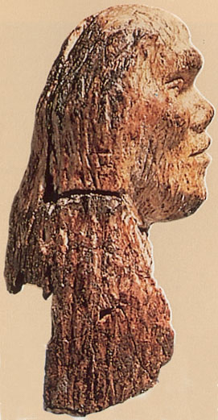 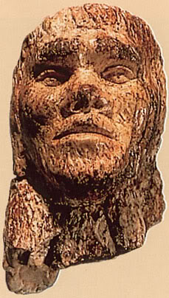 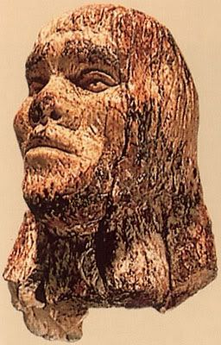

**Figs. 1-3.** Czech Republic-Dolni Vestonice-Bust-Male-29,000-22,000 BP

**Formal Label:** Czech Republic-Dolni Vestonice-Bust-Male-29,000-22,000 BP

**Display Description:** This head of a Cro-Magnon man dating to 29,000-22,000 BP may be a self-portrait, carved in mammoth ivory, and his protruding brow has a counterpart in a skull that was excavated not too far from the spot where this figurine was claimed to have been found.

**Accession Number:** A000

**LC Classification:** GN772.22.C95

**Date or Time Horizon:** 29,000-22,000 BP

**Geographical Area:** Moravia in the Czech Republic, on the hill of Pollau.

**Map, GPS 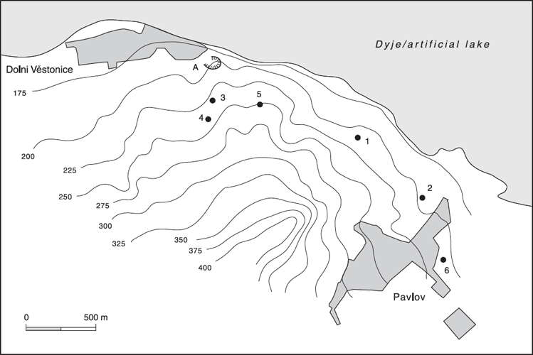Coordinates:** 48.88826 16.64364.

Fig. 2. Relief map showing Upper Paleolithic sites along the northeast side of the Pollau Hill. Dark line is the Dyje River. After Verpoorte (2000). Key: 1. Dolní Věstonice I; 2. Pavlov I; 3. Dolní Věstonice II; 4. Dolní Věstonice II-A; 5. Dolní Věstonice III; 6. Pavlov II.

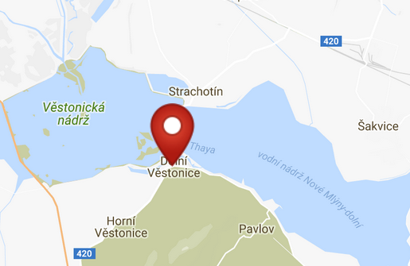 

Fig. 3. Map of Dolni Vestonici. Fig. 4. Location of Dolni Vestonici in Europe.

Fig. 5. Map of Dolni Vestonici within Europe. After <http://latitude.to/img/latitude-logo.svg>

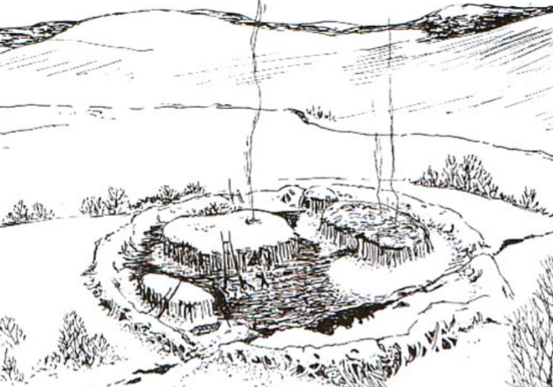

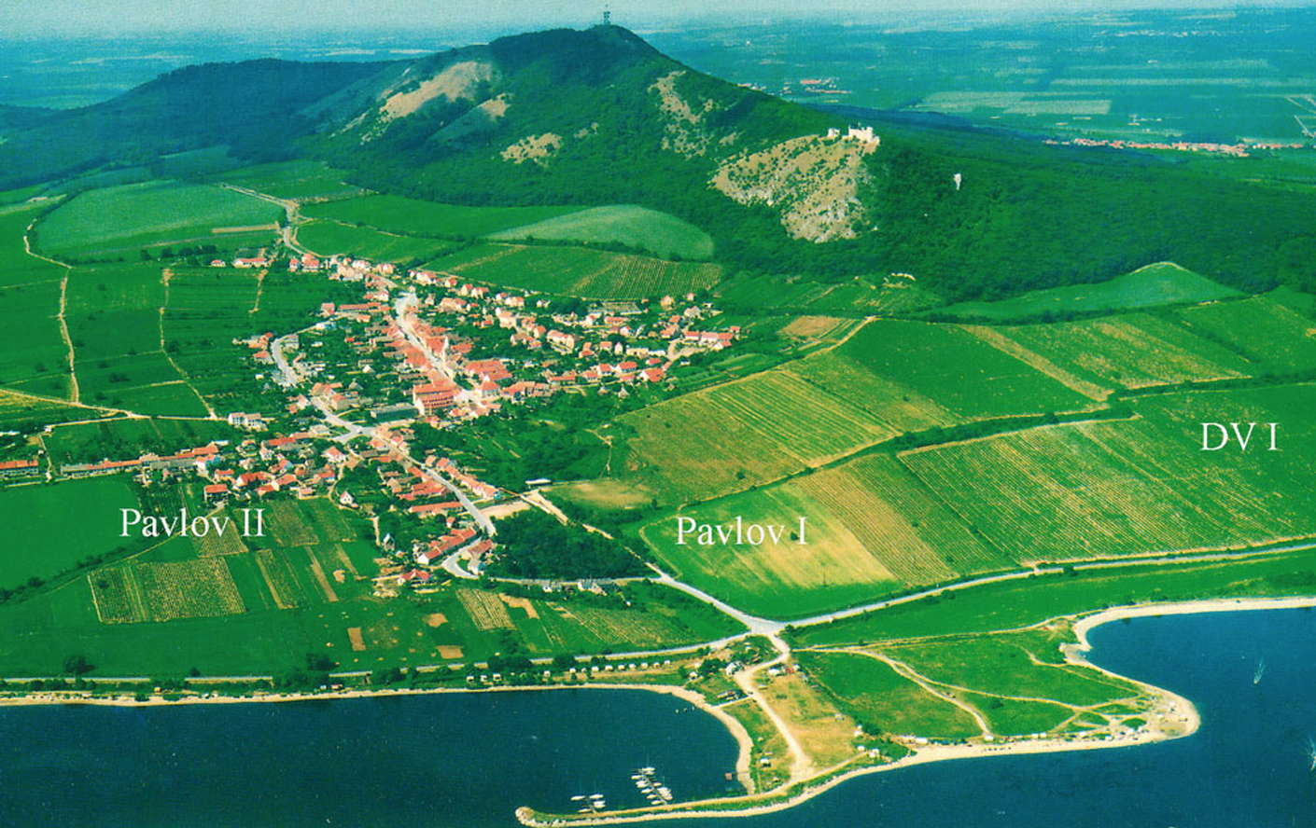

Fig. 6. View of Dolní Věstonice, Moravia, Czech Republic, 29,000 BP, after <http://humanpast.net/images/dolni.JPG>.

Fig. 7. Aerial view of Dolní Věstonice, Moravia, Czech Republic, 2004, after Svoboda (2007)

**Cultural Affiliation:** Gravettian period

**Medium:** Mammoth ivory

**Dimensions:** H 3.34 in, 84.83 mm; W 1.45 in, 31.11 mm.

**Weight: resin replica 35.1 gm’ original n/a.**

**Condition: museum replica in resin.**

**Provenance:** unknown

**Discussion:**

“The only other human head from the Ice Age that had eye sockets, eyeballs, and lids was the realistically carved female with a bun excavated in a 26 000 year level at Dolni Vestonice. Pieces of the ivory lamellae, like layers of an onion, had flaked off, leaving an uneven surface and an unfinished look. Later when Alexander Marshack reexamined this head in Czechoslovakia, and cleaned it he found incised nostrils, a detail not noted before, that resembled the style of the male head. Were these accidental similarities or aspects of a regional Ice Age style?  
  
His initial microscopic analysis indicated that the male head had been broken in several places, glued together, and covered with a protective coating. He was told by the owners that the piece had been dipped in horse glue, once a common method of preserving bone. The ivory had apparently been shaped with flint tools. Many grooves were striated and changed configuration as the line curved. A steel blade would not make these patterns. Some strokes were overlaid with encrustations of sand and minerals that had apparently accumulated over time. Natural cracks, also filled with minerals, crossed the engraved lines, suggesting that weathering had occurred after the piece was carved.  
  
The bottom had been sawed horizontally at about the shoulder line. Marshack had seen fine-toothed blades from the Dolni Vestonice collection that might, when hafted, have been used to saw ivory in this way. The nostrils and eyes presented a special problem. They appeared to have been cleaned, and even recarved, and then covered with paraffin.  
  
The protruding brow is similar to that on a skull found in Brno, Czechoslovakia, in 1891.  
  
X-ray diffraction at the Peabody Museum revealed the presence of iron oxides, which give the artifact its reddish brown coloration, and fluorapatite, the result of an exchange between the ivory and minerals in the soil. Both suggest long burial in the ground.  
  
The British Museum had seen the piece once before. In the late 1940s the museum had been asked to authenticate the piece but had to return it when the owners moved to Australia; the museum may have put the paraffin in the eyes as a preservative. Museum experts now told Marshack it would be difficult, if not impossible, to fake the complex changes that had occurred in the ivory.  
  
Clearly the ivory needed to be dated, and, more important, the carving itself. Accelerator carbon-14 dating was not feasible because it would consume a portion of the statuette. Marshack contacted Dr. Edward Zeller, director of the Radiation Physics Lab at the University of Kansas Space Technology Center, who became intrigued with the problem. He suggested alpha-particle spectral analysis to locate radioactive elements useful in estimating age. Working with fragments at first, Ed found uranium in surprising quantities. Uranium would enter the tusk only after its burial in sediment or sand where groundwater containing traces of uranium was seeping. More startling were the high counts of radium and other radioactive products of uranium decay.  
  
While Ed was testing, Marshack detoured to Czechoslovakia on his way to a conference in Italy. He wanted to learn about soil conditions in the area of Dolni Vestonice and confer with Dr. Klima. He learned that uranium, a valued resource after World War II, had been located in the highlands northwest of Brno. Rainwater draining these heights may have reached the lowlands where the head was reportedly found. Klima said, 'We have so many unique things from Dolni Vestonice and Brno -the 'marionette', the oldest fired clay figures, the 26 000 year old female head - it would not surprise me to find here the oldest male image.'  
  
Back in Kansas, Ed Zeller and his associate Dr. Wakefield Dort, Jr., a Pleistocene geologist now had the carved hair piece to test. They placed it in the counting chamber of the alpha particle spectrometer for 72 hours. The final ratios of uranium to decay products suggested that the carved surface of the ivory may be about 26 000 years old.  
  
The scientists envision this Ice Age scenario: Sometime after a mammoth died, someone carved a piece of its tusk. The carving became buried in sediment or sand, where it absorbed uranium, iron oxide, and fluoride from the groundwater. The calcium phosphate of the ivory absorbed the minerals, especially the uranium. At the same time, radioactive decay set in, leaving its by-products at levels that require thousands of years to build up to the present reading. If the head had been carved anytime in the past few centuries, the decay products on the surface would have been cut away. 'Even Madam Curie couldn't fake that effect.' Ed said. He and Dort have no doubt that the carving is ancient, but the precise age has yet to be confirmed” (Marshack 1988).

REFERENCE

Marshack, Alexander, “Astonishing Ice age discovery: Oldest realistic human Portrait?" *National Geographic*, October 1988.